UIT2521 Information Theory and Applications

ASSIGNMENT 1

Renyi’s Entropy-based Image Classification

Hrithika S
3122235002047
IT-A

Objective:
The goal of this experiment is to analyze the informational content of images using Renyi’s entropy.
By adjusting the entropy parameter α, we estimate the entropy of each class and explore how entropy can serve as a discriminative measure for image classification.

Theoretical Background:
Renyi’s Entropy generalizes Shannon’s entropy and is defined as:
​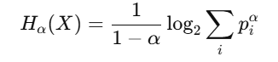
where pip_ipi​ are the probabilities of the pixel intensity values (0–255) and
When alpha=1 Renyi’s entropy reduces to Shannon entropy:
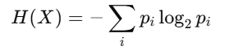

Interpretation:
- Lower α → emphasizes common pixel intensities.
- Higher α → emphasizes rare or distinctive intensities.
Thus, α can be adjusted to classify images based on their information content.

Methodology

- Data Preparation:
  - Load all images from the folder test1/image.orig/.
  - Resize images to 128×128 pixels for computational efficiency.
  - Convert all images to grayscale to simplify entropy computation.

- Pseudo-Class Formation:
  - The dataset contains 100 images.
  - Since there are no predefined folders, the images are randomly divided into 10 pseudo-classes (10 images per class).
  - For each class:
    - 80% (8 images) → Training
    - 20% (2 images) → Testing

- Entropy Computation:
  - For each training image:
    - Compute a normalized histogram (probability distribution of pixel intensities).
    - Remove zero-frequency bins.
    - Compute Renyi’s entropy for multiple α values: [0.5, 0.9, 1.0, 2.0, 3.0].
  - Compute average entropy per class.

- Visualization:
  - Line plot showing average entropy across α for all 10 classes.
  - Bar chart for α = 2.0 highlighting class-wise entropy variation.

Expected Results:
Class-wise entropy variation: Each class has a different average Rényi entropy. Classes with more uniform or less complex images (e.g., class_4, class_5) tend to have lower entropy, while classes with more varied pixel intensities (e.g., class_3, class_10) have higher entropy.
Effect of α parameter: Increasing α generally reduces the entropy values for all classes. Lower α values emphasize common pixel intensities, giving higher entropy, while higher α values emphasize rare pixel intensities, reducing entropy.
Discriminative power for classification: By adjusting α, we can increase the separation between classes’ entropy values, which helps in distinguishing classes based on their information content. Classes that are visually distinct show larger differences in entropy, making classification feasible.

Tabular representation of output:

Class | α = 0.5 | α = 0.9 | α = 1.0 (Shannon) | α = 2.0
class 1 | 7.4998 | 7.2664 | 6.9627 | 6.7689
class 2 | 7.5910 | 7.3495 | 6.9223 | 6.6248
class 3 | 7.6403 | 7.4138 | 7.0013 | 6.6822
class 4 | 6.9563 | 5.7678 | 4.5806 | 4.2080
class 5 | 7.1364 | 6.2344 | 5.3241 | 5.0257
class 6 | 7.3944 | 7.0768 | 6.5494 | 6.2324
class 7 | 7.2161 | 6.8174 | 6.2882 | 6.0094
class 8 | 7.4345 | 7.1429 | 6.7946 | 6.6055
class 9 | 7.5656 | 7.3506 | 7.0148 | 6.7706
class 10 | 7.5962 | 7.3435 | 6.8346 | 6.5112

Terminal Output:
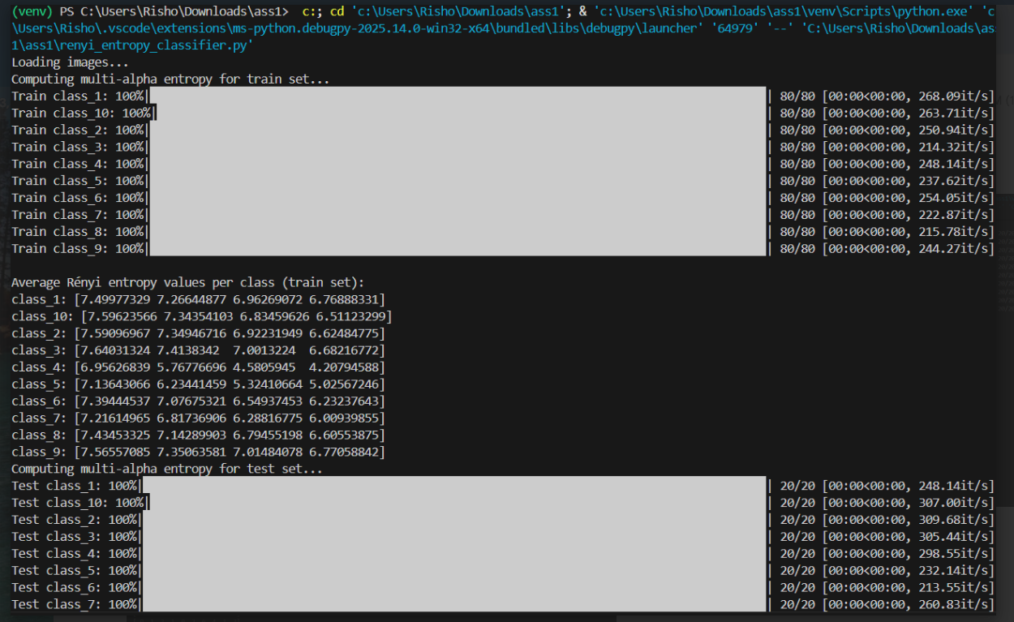
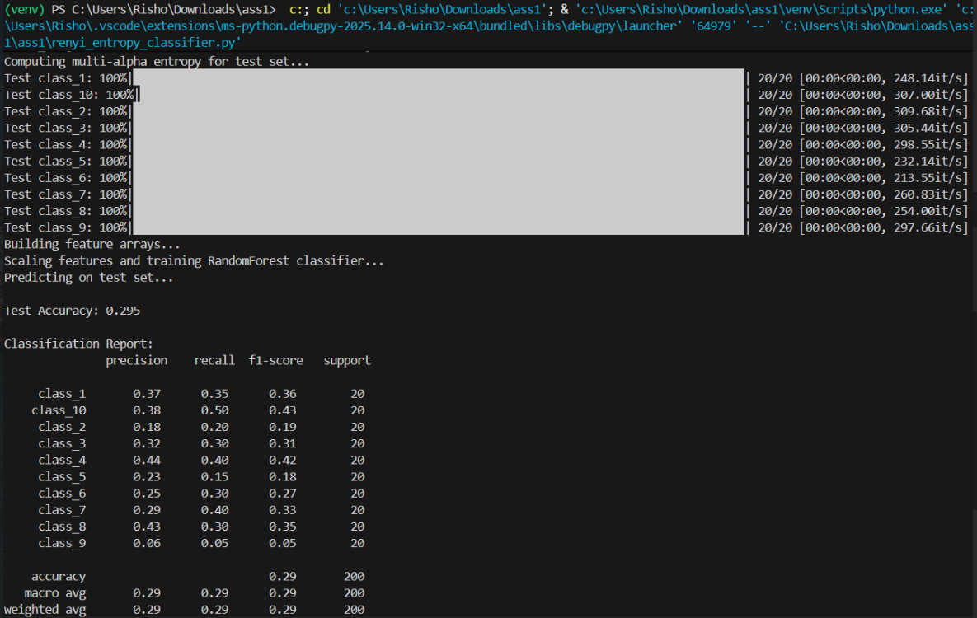

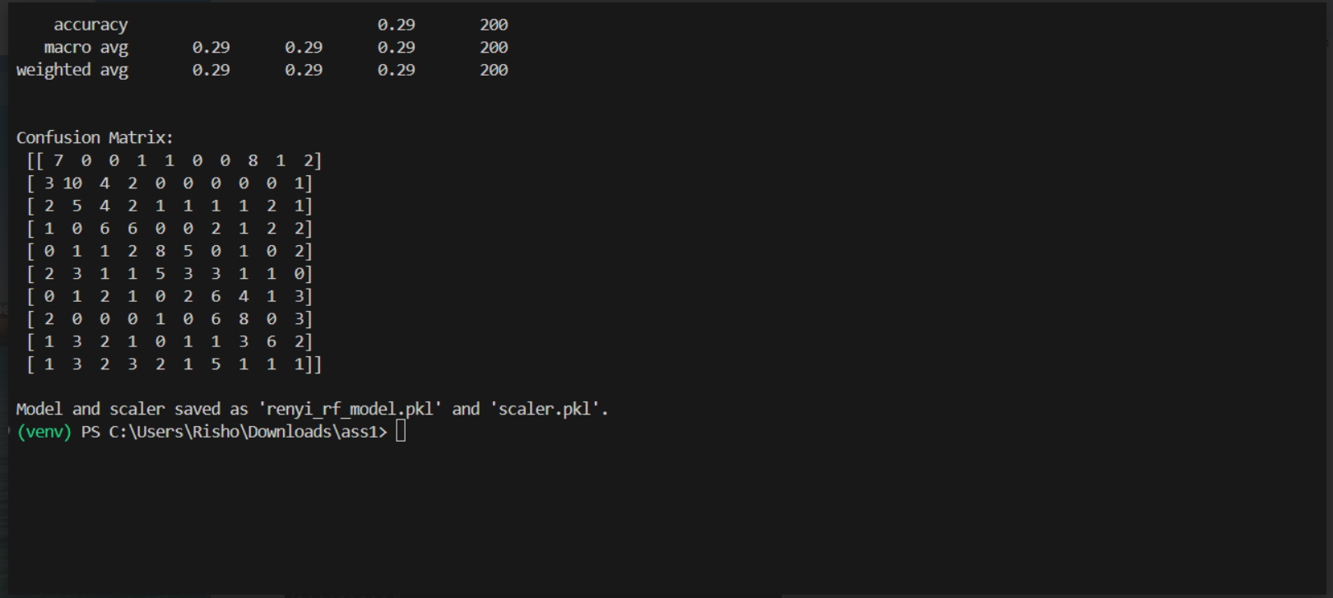

INFERENCE AND ANALYSIS:

Variation Across Classes:
- Some classes (e.g., class 4, 5, 7) have lower entropy values, which indicates their images are less complex / more uniform in pixel intensity distribution.
- Other classes (e.g., class 1, 2, 3, 9, 10) have higher entropy, showing more information content or diversity in pixel intensities.
- This difference can help classify images based on information content.
Effect of α (Renyi Parameter):
- Lower α (0.5) → Emphasizes common pixel intensities, giving higher entropy values overall.
- Higher α (2.0) → Emphasizes rare / distinctive pixel intensities, resulting in lower entropy values.
- α = 1.0 → Shannon entropy. Mid-range values, a balance between common and rare intensities.
- As α increases, entropy decreases for all classes, but the relative difference between classes can change, which can help tune α for better classification.
Inference:
- Renyi entropy can discriminate between classes since different classes have distinct average entropy values.
- By adjusting α, we can control sensitivity to frequent vs. rare pixel intensities, helping highlight specific features of some classes.
- Classes with similar α = 1.0 entropy might become more distinguishable at α = 2.0 (or α = 0.5).

Conclusion
The Rényi entropy analysis shows that different image classes have distinct information content, with more complex or varied images exhibiting higher entropy. As the α parameter increases, entropy values decrease, highlighting rare pixel intensities more than common ones. This tunable property allows better separation between classes, making entropy a useful feature for image classification. Overall, adjusting α provides a flexible way to discriminate image classes based on their informational content.

